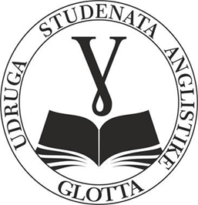
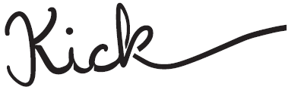
●

KICK – Students’ journal ● The English Students’ Association “Glotta”
Faculty of Humanities and Social Sciences ● Josip Juraj Strossmayer University of Osijek ● Lorenza Jägera 9, 31 000 Osijek
: kick.ffos2@gmail.com ● ISSN (Print): 2623-9558

Dear colleagues,
We cordially invite you to submit your papers for the students’ journal Kick. Kick is a student scholarly journal with a double-blind review process published by the Faculty of Humanities and Social Sciences, University of Osijek. The journal welcomes submissions of original research papers, preliminary communications, review papers, professional papers and reviews in the field of literary studies and related fields of humanities and social sciences, such as film, TV, games, art and others. The journal contains a section on creative writing and welcomes contributions in the form of students’ creative work (poetry and short stories).
The journal’s main purpose is to develop a platform for young scholars and students of English language and literature through which they can contribute to the development of literary studies and exchange their knowledge in the study of literature and literature-related topics.
The journal is published once a year. We accept submissions written exclusively in the English language. Papers submitted by 14 July will be considered for publication in the current year. Papers received after that date will be considered for publication in the following year. The papers are to be submitted to the journal’s Editorial Board via the following e-mail: kick.ffos2@gmail.com.

We are looking forward to your papers!
The Editorial Board of Kick

