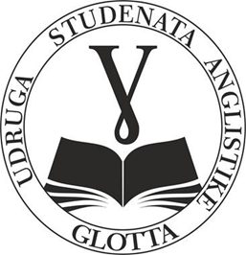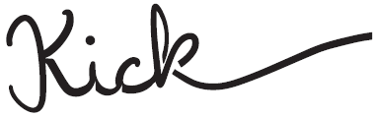

●

**KICK** – Students’ journal ● The English Students’ Association “Glotta”

Faculty of Humanities and Social Sciences ● Josip Juraj Strossmayer University of Osijek ● Lorenza Jägera 9, 31 000 Osijek

🖂: [**kick.ffos2@gmail.com**](mailto:kick.ffos2@gmail.com) ● ISSN (Print): 2623-9558

Dear colleagues,

We cordially invite you to submit your papers for the **students’ journal *Kick***. *Kick* is a student scholarly journal with a **double-blind review process** published by the Faculty of Humanities and Social Sciences, University of Osijek.There is no theme for the journal. Therefore, the journal welcomes any submissions. The journal welcomes submissions of original research papers, preliminary communications, review papers, professional papers and reviews in the field of literary studies and related fields of humanities and social sciences, such as film, TV, games, art and others. The journal contains a section on creative writing and welcomes contributions in the form of students’ creative work (poetry and short stories).

The journal’s main purpose is to develop a platform for young scholars and students of English language and Literature through which they can contribute to the development of literary studies and exchange their knowledge in the study of literature and literature-related topics.

The journal is published once a year. We accept submissions written exclusively in **the English language**. Papers submitted **no later than 1 August 2024** will be considered for publication in the current year. The papers are to be submitted to the journal’s Editorial Board via the following e-mail: [**kick.ffos2@gmail.com**](mailto:kick.ffos2@gmail.com).

We are looking forward to your papers!

The Editorial Board of *Kick*

**About *Kick***

From its inception, students’ journal Kick had one simple purpose, to provide students  
at the Faculty of Humanities and Social Sciences in Osijek with an easy and simple way to  
publish both their academic and creative writing in English. Students wholeheartedly accepted  
this opportunity and, as a result, Kick has already had three online issues in 2018 containing  
students’ research papers, poems, short stories, and reviews. In 2019 Kick published its first two printed issues. It continued with its activities in 2020, now as a double-blind reviewed journal and a part of the English Student’s Association “Glotta.” This issue finally sees the light of day after a lengthy hiatus. It demonstrates the students' exceptional ingenuity, originality, and wisdom. Despite numerous obstacles and difficulties, it effectively captures the artistic, observational side of our colleagues. At last, for all questions Editorial Board answers via email: kick.ffos2@gmail.com.