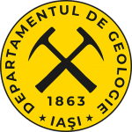
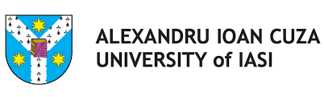

Earth’s Resources: From Natural Riches to Cultural Riches

Blended Intensive Programme
“Alexandru Ioan Cuza” University of Iași, Romania

Call for partners

What is it about?

This program explores natural resources (minerals, oil, salt, mineral water, thermal water) both from a geological perspective and a cultural viewpoint.

It blends the theoretical framework provided by means of interactive lectures held by experts from the fields of Geology, Geography, Chemistry, History, Theology and the Arts, with practical activities such as mineral identification and modelling, chemical analyses of mineral water composition, identification of various types of crude oil etc., and visits to various sites of cultural and historical significance in Iași and Bukovina.

The main objective of the program is to allow participants to deepen their understanding of the ways in which natural resources are formed, extracted and utilized, and of the imprint they can leave upon the history and culture of a country.

Where?

“Alexandru Ioan Cuza” University of Iași, Romania

When?

On-site (Iași, Romania): March 30th – April 3rd, 2026
Online: March 24th – 26st, 2026 and April 7th – 8th, 2026

Who should attend?

The program is designed for both undergraduate and graduate students from the fields of Geology, Geography, Chemistry, History, Theology and the Arts who are interested in interdisciplinary learning, exploring cross-cultural perspectives and building international networks.

Learning outcomes

The Blended Intensive Programme Earth’s Resources: From Natural Riches to Cultural Riches is designed to deliver the following key learning outcomes:

- Advanced understanding of the geology of natural resources and their cultural impact
- Enhanced comparative analysis and communication skills
- Multicultural perspective
- Practical tools usable when conducting research on natural resources and their applications

Benefits

3 ECTS Credits

Course structure. Main topics

The main topics covered are as follows:

- the geology of minerals, oil, salt, mineral and thermal water
- mineral pigments used in the painting of the frescoes of Bukovinian monasteries
- gemstones referenced in the Bible
- the history of oil and salt exploitation on Romanian territory
- thermal and mineral water sources
- the geological and cultural heritage across borders

By the end of the program, participants will complete a collaborative task which will allow them to apply the concepts learned.

The event also includes coffee breaks and social activities organized by the program coordinators, providing opportunities for networking and informal discussions.

